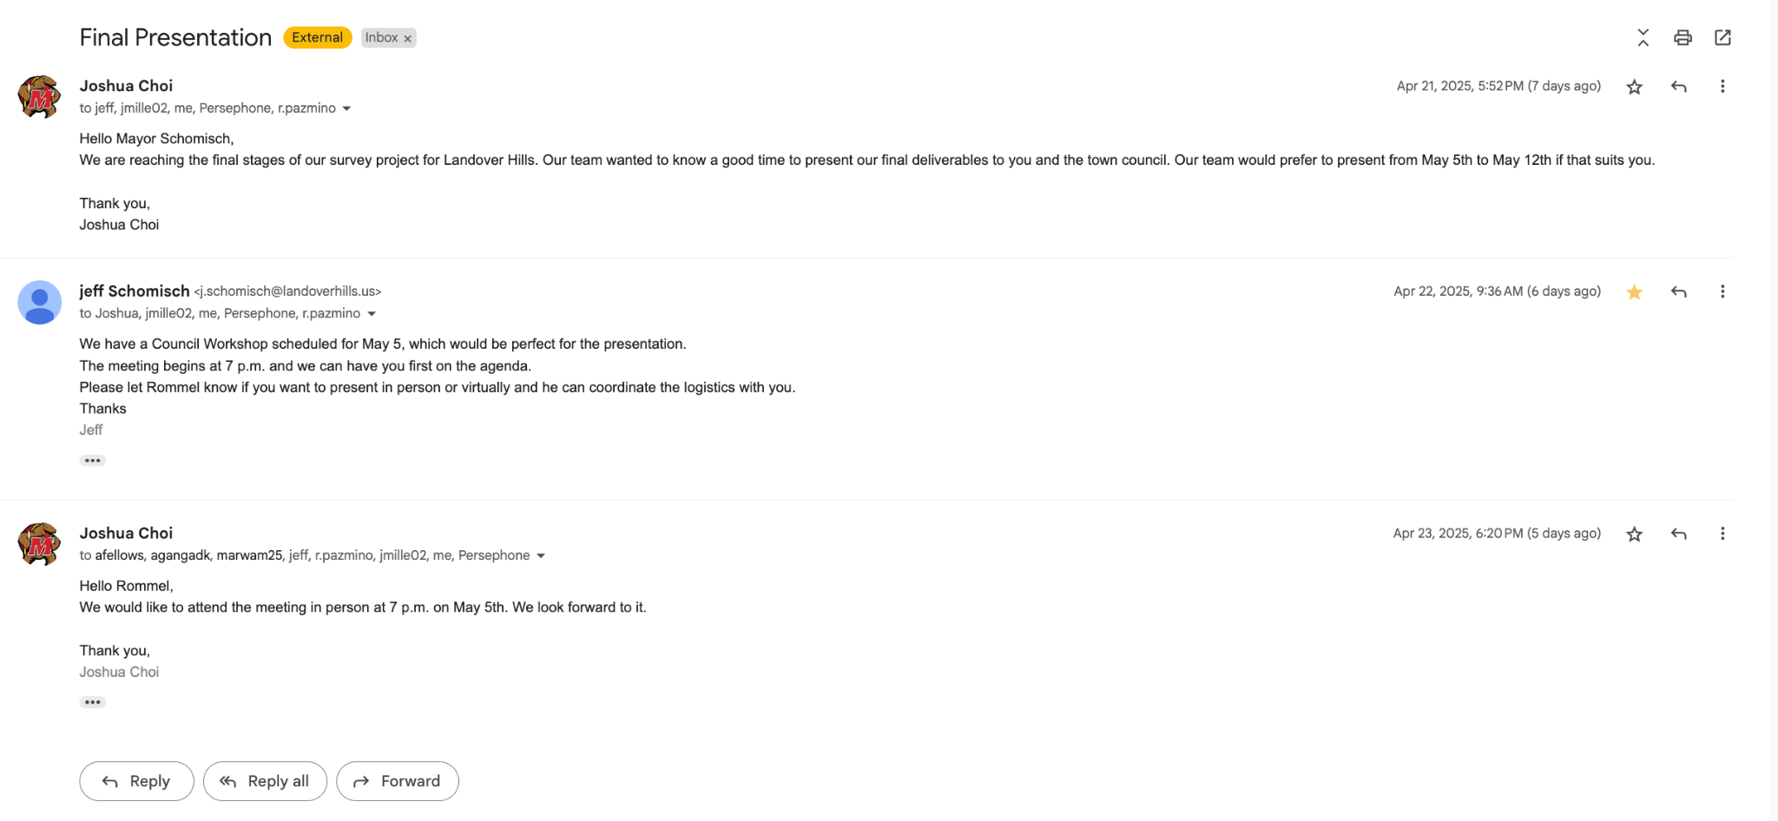

Although we didn’t have a zoom meeting with the mayor, we had a short chain of email conversation talking about our presentation and when we scheduled to do the final presentation to him and the council.